Nutrient enrichment and associational effects impact variability in herbivory and herbivore growth of the generalist Spodoptera exigua on the crop Brassica oleracea
Stacey L. Halpern¹, Alissa Cole¹, Mason Hoskins¹, Nahaku Kekauoha¹, Shaznae Marsh², Marley Shouldice², Jessie Mutz², Brian D. Inouye², and Nora Underwood²
¹Pacific University, ²Florida State University

Abstract

Introduction

Methods
Study System and Propagation
We used a crop-agricultural pest system for these greenhouse experiments. The herbivore was the generalist Spodoptera exigua (Lepidoptera), which is native to Southeast Asia and invasive in North America (Greenberg et al., 2001). We purchased eggs (Benzon Research, Pennsylvania, USA) and reared them on artificial diet (Southland Products Inc., Arkansas, USA) in incubators (12-hour light cycle, 24-29° C modified to control developmental timing as needed). Before trials began, we acclimated larvae to feeding on plants by feeding them kale leaves for 24-48 hours.
The host plants were two Brassicaceae: Brassica oleracea var. sabellica (Russian Red Kale) and Brassica juncea var. FILL IN (NAME OF MUSTARD VARIETY). We grew plants in greenhouses under natural light, using heat mats in Oregon to increase germination rates. Plants grew in 8.9 cm² pots containing ProMix HP Mycorrhizae soil (Premier Horticulture Inc., Pennsylvania, USA); except for plants in the “no fertilizer” treatment, we mixed about 2.5 ml of 14-14-14 Osmocote Smart Release Plant food (The Scotts Company, Ohio) into the soil at planting. We overplanted seeds in 8.9 cm² pots and thinned to one plant per pot after seedling establishment. Plants grew until they reached X size, approximately X weeks, before trials started.
Experimental Design
We carried out two sets of factorial experiments, each with temporal replicates. In both experiments, an experimental unit consisted of groups of six individually-potted plants and six S. exigua larvae (Fig. 1). We assigned each experimental unit a larval movement treatment: no movement (individual plants bagged with INSERT NAME OF BAG, confining larvae to single plants) or movement (sets of six plants bagged together, with pots touching to allow larvae to move between plants). In the nutrient enrichment experiment, each experimental unit consisted of either 6 fertilized or 6 unfertilized plants (Fig. 1). In the associational effects experiment, each experimental unit consisted of either 6 kale plants (same neighbor) or 3 kale plants with 3 mustard plants (different neighbor, Fig. 1). In both experiments, each temporal block included three replicates (larval movement x fertilizer or neighbor), for a total of 12 experimental units/72 plants/72 larvae. There were four temporal replicates for each experiment, for a total of 48 experimental units/288 plants/288 larvae per experiment. All associational effects trials occurred in Oregon; half the nutrient enrichment trials occurred in Oregon greenhouse and half in Florida. We collected data on plant damage levels and larval growth after 24-48 hours of feeding.
Response variables
We calculated two measures of leaf damage levels: percent damage and absolute damage. For percent damage, we visually estimated percent herbivory for each leaf on every plant to the nearest 1%, then calculated the mean percent leaf damage per plant. We also used individual leaf damage estimates to calculate the coefficient of variation in herbivory for each plant. For absolute leaf damage, we estimated leaf area consumed by multiplying a plant’s estimated total leaf area by its mean percent leaf damage. We used linear regression to estimate total leaf area. For all plants, we counted the number of leaves and measured the length of the longest leaf. For a subset of plants, we also measured total leaf area using LeafByte (Getman-Pickering et al., 2019). We then used NAME OF MODEL (add R citation) to estimate total leaf area based on plant size (longest leaf length x leaf number).
We also used larval relative growth rates (RGR) as a measure of plant quality/plant resistance to herbivores. We calculated RGR as ln(final mass) – ln(initial mass). To clear guts before each weighing, we starved larvae for 1 hour. In the no movement treatment, we could track individual larvae in trials so collected initial and final weights of each one. In the movement treatment, we could not identify individual larvae in trials, so we weighed them as a group and then averaged their initial and final weights. Some larvae disappeared in trials. For the no movement treatment, we dropped these larvae from analyses. For the movement treatment, we calculated the average final mass using only the recovered larvae.
Data Analysis
We conducted all analyses in R (add citation).
To determine whether variances differed among treatments, we used Levene’s tests. For each response variable (mean percent leaf damage, absolute leaf damage, and larval RGR), we first tested for overall differences in variances amongst all the treatments. To account for differences among temporal blocks, location (Florida vs. Oregon), and host plant in the associational effects experiment, we used residuals from ANOVAs (using lm) as the response variable in these tests. When we detected overall differences in variances among treatments, we determined which of the treatment combinations differed using a series of post-hoc Levene’s pairwise tests.
To test within-plant variation in percent damage we used a linear mixed model (lmer in RStudio, lme4 package). For both experiments, the predictors included temporal block and larval movement; to account for the grouping of individual plants in clusters in the movement treatment, we also included individuals nested within clusters.
Results
Nutrient Enrichment Experiment
Kale plants that received fertilizer were overall larger than those that were left unfertilized. The longest leaf length of fertilized kale plants ranged from 4.0-14.6 centimeters, while the unfertilized ones ranged from 3.1-11.2 centimeters. Plants had 2 to 8 leaves prior to experimentation, with fewer leaves on the unfertilized plants compared to the fertilized plants. Additionally, the leaves of the unfertilized plant were observed to be purple in color and exhibited more trichomes resulting in a rougher texture compared to the fertilized plants that were green and exhibited a softer texture.
Overall, nutrient enrichment and movement each affected the among plant variance in all three response variables (Figures 2, 4, and 6). The effects of larval movement on variance were not consistent across treatments and changed based on the presence or absence of fertilizer (see below).
Relative Growth Rate- Fertilization and movement affected overall variance in the relative growth rate of Spodoptera exigua (Levene’s test, df = 13,132, p<0.001). Overall, fertilized plants had lower variance in larval RGR than unfertilized plants, driven by the significantly greater variation in fertilized plants than unfertilized plants in the absence of movement (Figure 2, Table S1). In addition, preventing larval movement increased variation in larval RGR only in the fertilized plants. The RGR for S. exigua had values ranging from -0.79 g/g/day to 1.11 g/g/day. In many instances after the allotted feeding time S. exigua were not found on the plants but instead were on the side of the mesh bag at the end of the trail, likely contributing to negative RGR observations. Further, not all S.exigua could be located after the experiment.
Mean Percent Damage- The overall variation of among-plant mean percent leaf damage was affected by the presence of fertilizer and movement (Levene’s test, df = 13, 238, p < 0.001, Figure 4). The levels of damage for unfertilized plants ranged from 0-78.3%, whereas fertilized plants had damage levels between 0-15.3%. In contrast to RGR results, unfertilized plants had higher variation in mean percent leaf damage, driven by the difference between fertilizer treatments when larvae could move (Figure 4, Table S1).
Mean Absolute Leaf Damage- Overall the variation of the absolute leaf damage was significantly affected by the presence of fertilizer and movement (Levene’s test, df = 13, 238, p < 0.001, Figure 6). Mean absolute leaf damage ranged from 0-21.9 cm². All post-hoc pairwise tests were statistically significant (Table S1). Without larval movement, unfertilized plants had higher variability in damage. The opposite effect was seen when larvae could move--among-plant variance increased with fertilizer. In the absence of fertilizer, no larval movement resulted in higher variance of damage. In contrast, with fertilizer, larval movement resulted in higher variance of damage.
Within Plant - Damage within plants was more variable under high levels of nutrients and ranged from -1.69 to 1.25 (Figure 8). Within plant variation was significantly affected by the presence of fertilizer (𝜒², df =1, p<0.001) and the interaction of fertilizer and movement (𝜒², df =1, p<0.01). Movement alone did not affect within plant variation (𝜒², df =1, p = 0.75).
Associational Effects Experiment
Mustard plants were overall larger in size and leaf length than the kale plants. The longest leaf length on kale plants ranged from 6.3-14.5 centimeters, while the mustard plants ranged from 7.2-17.5 centimeters. Kale plants started with 3-7 leaves per plant and mustard plants had 3-9 leaves per plant. Mustard plants had long smooth leaves appearing mostly green with a little bit of purple and little to no trichomes present to the touch. Kale plants were green and exhibited a soft texture.
Overall, associational effects and larval movement affected the variance in all three response variables (Figure 3, 5, and 7). Larval movement (cluster vs individual kale) affected variance in all three response variables, while neighbors (same or different) affected damage but not larval RGR (Table S2).
Relative Growth Rate - Larval RGR was significantly affected by host variation and larval movement (Levene’s Test, p< 0.001, df = 10,112). In kale monoculture, variation in larval RGR was higher without larval movement (Table S2). S. exigua RGR’s ranging from -2.01 to 1.69 g/g/day. When removing larvae from plants, they were often found on the side of mesh bags. Since larvae were not actively feeding for an allotted time, it likely contributed to negative larval RGR. In some instances, S. exigua could not be located.
Mean Percent Damage - The overall variation of among-plant mean percent leaf damage of S. exigua was significantly affected by associational effects and movement (Levene’s test, df = 11, 117, p < 0.001, Figure 5). Mean percent leaf damage ranged from 0 to 28.8 percent. Monoculture kale plants in the no movement treatment had higher variance in damage, driven by the absence of movement (Table S2). However, in the presence of larval movement, the diculture had higher variance than the kale monoculture.
Absolute Mean Leaf Damage - The overall variation in absolute leaf damage was significantly affected by associational effects and movement (Levene’s Test, df = 13, 238, p < 0.001, Figure 7). Mean absolute leaf damage calculated ranged from 0 to 27.62 cm². When larval movement was present in the kale monocultures, variance in damage increased. Comparing monocultures to dicultures, variance was higher in the dicultures than the monocultures.
Within Plant - The within-plant damage calculated using coefficient of variation was only significantly affected by temporal block (𝜒², df = 1, p = 0.02, Figure 9). While within-plant variability ranged from 0 to 2.65, associational effects and movement did not significantly affect the variance of damage found within each plant. In each treatment all plants received similar levels of damage.

Discussion
Our study shows that variability of herbivory damage amongst plants is affected by changes in the environment. While other studies have looked at nutrient availability or associational effects on the mean effect of damage, our study is the first to our knowledge to investigate how environmental changes affect the variability of herbivory damage among and within plants (Wetzel et al., 2016). Investigating the variability of plant or herbivore traits and defenses on damage levels has provided insight into plant and herbivore interactions' evolutionary and ecological trends (Gray et al., 2020; Moreira et al., 2017). Our findings shed light on nutrient enrichment and associational effects' influence on herbivore feeding behavior, specifically its spacial variability amongst plant individuals. The spatial variability of damage amongst plants may influence the reproductive ability or survivability of a plant in the community; as a result, the patterns could influence evolutionary trends to favor those who were minimally affected (Shiels et al., 2014). Additionally, spatial patterns of damage may shed light on herbivore behavior such as: preferential feeding, growth rate, and survivability. In poly-culture environments, understanding the spatial patterns of damage amongst different species in a community may help understand the rise and fall of species densities that lead to changes in species composition over time (Shiels et al., 2014). Furthermore, nutrient availability and associational effects' impact--prominent in agro-ecological environments--on the variability of damage a plant experiences may alter crop viability. Consequently, these findings hold additive economic importance due to the ever-changing environment resulting from human manipulation (Fuentealba et al., 2020).
The availability of limiting nutrients varies across landscapes; fertilizer application influences our agriculture systems by increasing limiting nutrients to increase plant biomass production (Lee et al., 2017). In our study shows that increased nutrient availability due to fertilizer lessens the variability of damage among plants. Although nutrient enrichment influences the levels of induced defenses (Lou & Baldwin, 2004), the corresponding time lags of these defenses extend beyond the timescale of our study (N. Underwood et al., 2005; N. C. Underwood, 1998), suggesting they are unlikely to contribute to our results. On the other hand, increased constitutive plant defenses resulting from nutrient enrichment (Stout et al., 1998) may reduce the variation of feeding damage among plants. Plant defenses may change herbivore behavior; for example, increased constitutive defenses may change leaf taste or quality, causing herbivores to reduce feeding or leave the plant in pursuit of another food source (N. Underwood et al., 2005). In avoidance of constitutive defense, the herbivore's moving and feeding between plants may reduce the variability of herbivore damage among plants (N. Underwood et al., 2005), as seen in our study. Additionally, nutrient enrichment increases the nutrient quality of the leaf tissues in the plant (Murage et al., 1996). Studies have observed leaf quality to affect herbivore behavior; herbivores may engage in compensatory feeding or exploration for better food sources when subject to nutritionally deficient food sources (Berner et al., 2005; Chen, Schmelz, et al., 2008). In contrast, nutritionally satisfied herbivores may be less likely to leave their food source (Chen, Schmelz, et al., 2008). In our study, a reduction in the variability of damage among nutrient-enriched plants, where the plant to herbivore ratio was one-to-one, may result from the lack of movement amongst plants by the herbivores due to being nutritionally fulfilled. We may infer that environments containing more fertile soils may experience more uniform damage levels among plants than less productive environments. These findings are significant when comparing agricultural ecosystems with more natural ecosystems; agroecosystems may experience more even damage amongst plants due to increased fertilizer usage than more natural ecosystems that may have nutrient limitations due to a lack of fertilization.
We found that associational effects resulted in an increase in variability of herbivory among plants. The selective grazing hypothesis suggests that a plant's palatability aids in its ability to repel or attract herbivores and, in a diverse setting, may cause associational resistance or susceptibility (Atsatt & Odowd, 1976; Hahn & Orrock, 2016). In our study, the focal plant (kale) may have had higher palatability as compared to its neighbor (mustard) due to the kale having increased mean damage levels than the mustard when clustered; as a result, the herbivore may prefer the kale over the mustard, resulting in associational susceptibility (Hahn & Orrock, 2016) for kale with mustard neighbors. Working in conjunction with the selective grazing hypothesis, increases in variability amongst the kale plants in a diculture setting could result from the spatial arrangement of the plants in the study. For both the monoculture and diculture studies, the leaves of each plant overlapped and entangled with each other. As a result, when an herbivore was feeding in the diculture, finding other kale plants may have been difficult, which could cause clumping in damage amongst the kale as the herbivore left the mustard plant in search of better food. In the monoculture, the herbivores only have one species option available, so they may roam, causing more even damage levels among plants. An herbivore's ability to access differing plant species may influence their feeding choice; studies have seen the importance of plant spatial arrangement in herbivore choice. For example, Hauri et al. (2022) found that changing the configuration of chemically diverse species caused a change in herbivore behavior. They varied the arrangement of plants along a transect: low-frequency chemical arrangement or clumped chemical diversity and high-frequency chemical arrangement or spread chemical diversity. As a result, they found that when the chemical diversity was equally accessible across the transect, there was an increase in herbivore clumping and reduced movement. They suggest that herbivores may balance their diet by feeding on chemically different plants. In contrast, they suggest that herbivores in monocultures roam in search of chemical diversity, increasing their movement and reducing the herbivore clumping (Hauri et al., 2022). We found similar results in our study. In the diculture setting, we found aggregated herbivore damage amongst the kale plants; in contrast, herbivores spread their damage amongst the plants in the monocultures. The aggregated damage in the diculture may be from the herbivores' ability to easily balance their diet due to the close proximity of a chemically diverse host (Hauri et al., 2022). In contrast, the even spread of damage in the monoculture may result from herbivore movement in search of a chemically diverse host to balance its diet (Hauri et al., 2022). To test this mechanism would require altering the spatial arrangement of the experimental cluster: changing the frequency of having similar or different neighbors in a cluster. Overall, in a di- or poly-culture environment, an herbivore can choose between plant species; if they are unsatisfied with the taste or smell, they may move to a different plant. This movement amongst plants and uneven consumption increases the variability of damage among plants, as recorded in our study.
Inherent in our study design, we found the herbivore's ability to move among plant individuals decreased the variability of herbivore damage. The effect of movement suggests that communities with higher densities would experience lower variability of damage among plants because herbivores with different feeding rates can move among the same plants, so their damage averages out, reducing the variability of damage among plants. Low-density environments would experience higher variability of damage among plants because the herbivores with differing feeding rates are on separate plants, highlighting their differences in feeding and increasing the variability of damage among plants. Our results support this; herbivores in non-movement environments had more variable RGRs than in movement environments (Figures 2 & 3). A caveat of this mechanism may be from averaging the herbivore RGRs in the movement treatment, resulting in an averaging effect rather than herbivore behavior.
Many of the mechanisms we propose to explain patterns of variability in damage rely on herbivore behavior. Further exploration of herbivore behavior is essential to understanding plant-herbivore interactions. Earlier research has observed gregarious (social) feeding by the larvae of insect herbivores (Choe & Crespi, 1997). Spatial clumping of herbivores is inherent in the mechanism of gregarious feeding; this clumped feeding of herbivores may increase the variability of damage within and among plants. Understanding these effects would explain how interactions within herbivore species change their feeding behavior, influencing evolutionary changes in community composition by hindering some individuals from reproducing due to extensive damage. Additionally, potential research may explore a field study in agroecosystems to test the trends seen in our lab investigation. Understanding the patterns of variability of damage seen in an agricultural setting would allow for better management of crops to reduce losses due to herbivore damage. Many of the mechanisms that alter the variability of herbivore damage are yet to be fully understood; exploration in this field would provide critical knowledge as to how these mechanisms change plant and herbivore populations over time.

Works Cited
Atsatt, P., & Odowd, D. (1976). Plant Defense Guilds. Science, 193(4247), 24–29. https://doi.org/10.1126/science.193.4247.24
Barbosa, P., Hines, J., Kaplan, I., Martinson, H., Szczepaniec, A., & Szendrei, Z. (2009). Associational Resistance and Associational Susceptibility: Having Right or Wrong Neighbors. Annual Review of Ecology Evolution and Systematics, 40, 1–20. https://doi.org/10.1146/annurev.ecolsys.110308.120242
Berner, D., Blanckenhorn, W. U., & Korner, C. (2005). Grasshoppers cope with low host plant quality by compensatory feeding and food selection: N limitation challenged. Oikos, 111(3), 525–533. https://doi.org/10.1111/j.1600-0706.2005.14144.x
Bolnick et al. (2011). Why intraspecific trait variation matters in community ecology. Trends in Ecology & Evolution, 26(4), 183–192. https://doi.org/10.1016/j.tree.2011.01.009
Champagne et al. (n.d.). Intraspecific variation in nutritional traits of neighbouring plants generates a continuum of associational effects—Champagne—2020—Journal of Vegetation Science—Wiley Online Library. Retrieved April 2, 2022, from https://onlinelibrary.wiley.com/doi/abs/10.1111/jvs.12914
Chen, Y., Ruberson, J. R., & Olson, D. M. (2008). Nitrogen fertilization rate affects feeding, larval performance, and oviposition preference of the beet armyworm, Spodoptera exigua, on cotton. Entomologia Experimentalis Et Applicata, 126(3), 244–255. https://doi.org/10.1111/j.1570-7458.2007.00662.x
Chen, Y., Schmelz, E. A., Waeckers, F., & Ruberson, J. R. (2008). Cotton Plant, Gossypium hirsutum L., Defense in Response to Nitrogen Fertilization. Journal of Chemical Ecology, 34(12), 1553–1564. https://doi.org/10.1007/s10886-008-9560-x
Chiu, Y.-C., Juvik, J. A., & Ku, K.-M. (2018). Targeted Metabolomic and Transcriptomic Analyses of “Red Russian” Kale (Brassicae napus var. Pabularia) Following Methyl Jasmonate Treatment and Larval Infestation by the Cabbage Looper (Trichoplusia ni Hübner). International Journal of Molecular Sciences, 19(4), E1058. https://doi.org/10.3390/ijms19041058
Choe, J. C., & Crespi, B. J. (1997). The evolution of social behavior in insects and arachnids. Cambridge University Press.
Coley, P. D. (1983). Intraspecific Variation in Herbivory on Two Tropical Tree Species. Ecology, 64(3), 426–433. https://doi.org/10.2307/1939960
Ebeling, A., Strauss, A. T., Adler, P. B., Arnillas, C. A., Barrio, I. C., Biederman, L. A., Borer, E. T., Bugalho, M. N., Caldeira, M. C., Cadotte, M. W., Daleo, P., Eisenhauer, N., Eskelinen, A., Fay, P. A., Firn, J., Graff, P., Hagenah, N., Haider, S., Komatsu, K. J., … Blumenthal, D. M. (2021). Nutrient enrichment increases invertebrate herbivory and pathogen damage in grasslands. Journal of Ecology, 110(2), 327–339. https://doi.org/10.1111/1365-2745.13801
Fuentealba, M., Latorre, C., Frugone-Alvarez, M., Sarricolea, P., Giralt, S., Contreras-Lopez, M., Prego, R., Bernardez, P., & Valero-Garces, B. (2020). A combined approach to establishing the timing and magnitude of anthropogenic nutrient alteration in a mediterranean coastal lake- watershed system. Scientific Reports, 10(1), 5864. https://doi.org/10.1038/s41598-020-62627-2
Gray, H. L., Andow, D. A., & Kiritani, K. (2020). Investigating the Movement Components of Host Preference in a Highly Mobile Insect Herbivore, Nephotettix cincticeps (Hemiptera: Cicadellidae). Environmental Entomology, 49(1), 115–122. https://doi.org/10.1093/ee/nvz128
Greenberg, S. M., Sappington, T. W., Legaspi, B. C., Liu, T. X., & Setamou, M. (2001). Feeding and life history of Spodoptera exigua (Lepidoptera: Noctuidae) on different host plants. Annals of the Entomological Society of America, 94(4), 566–575. https://doi.org/10.1603/0013-8746(2001)094[0566:FALHOS]2.0.CO;2
Hahn, P. G., & Orrock, J. L. (2016). Neighbor palatability generates associational effects by altering herbivore foraging behavior. Ecology, 97(8), 2103–2111. https://doi.org/10.1002/ecy.1430
Hauri, K. C., Glassmire, A. E., Randall, B., Zehr, L. N., & Wetzel, W. C. (2022). Plant chemical diversity and its frequency have distinct but complementary effects on insect foraging. Journal of Applied Ecology, 59(5), 1362–1371. https://doi.org/10.1111/1365-2664.14151
Holmes, K. D., & Agrawal, A. A. (2021). Induced resistance mitigates the effect of plant neighbors on susceptibility to herbivores. Ecosphere, 12(1), e03334. https://doi.org/10.1002/ecs2.3334
Holyoak and Wetzel. (2020). Variance-Explicit Ecology: A Call for Holistic Study of the Consequences of Variability at Multiple Scales. https://escholarship.org/content/qt62j8b207/qt62j8b207_noSplash_a017bd4dd283fbd48904b175ace2dc1f.pdf
Lee, M.-S., Wycislo, A., Guo, J., Lee, D. K., & Voigt, T. (2017). Nitrogen Fertilization Effects on Biomass Production and Yield Components of Miscanthus ×giganteus. Frontiers in Plant Science, 8. https://www.frontiersin.org/article/10.3389/fpls.2017.00544
Lind, E. M., La Pierre, K. J., Seabloom, E. W., Alberti, J., Iribarne, O., Firn, J., Gruner, D. S., Kay, A. D., Pascal, J., Wright, J. P., Yang, L., & Borer, E. T. (2017). Increased grassland arthropod production with mammalian herbivory and eutrophication: A test of mediation pathways. Ecology, 98(12), 3022–3033. https://doi.org/10.1002/ecy.2029
Lloyd-Smith, J. O., Schreiber, S. J., Kopp, P. E., & Getz, W. M. (2005). Superspreading and the effect of individual variation on disease emergence. Nature, 438(7066), 355–359. https://doi.org/10.1038/nature04153
Lou, Y. G., & Baldwin, I. T. (2004). Nitrogen supply influences herbivore-induced direct and indirect defenses and transcriptional responses to Nicotiana attenuata. Plant Physiology, 135(1), 496–506. https://doi.org/10.1104/pp.104.040360
Lu, C., & Tian, H. (2017). Global nitrogen and phosphorus fertilizer use for agriculture production in the past half century: Shifted hot spots and nutrient imbalance. Earth System Science Data, 9(1), 181–192. https://doi.org/10.5194/essd-9-181-2017
Mattson, W. J. (1980). Herbivory in Relation to Plant Nitrogen Content. Annual Review of Ecology and Systematics, 11(1), 119–161. https://doi.org/10.1146/annurev.es.11.110180.001003
Merkx-Jacques, M., Despland, E., & Bede, J. C. (2008). Nutrient utilization by caterpillars of the generalist beet armyworm, Spodoptera exigua. Physiological Entomology, 33(1), 51–61. https://doi.org/10.1111/j.1365-3032.2007.00604.x
Moreira, X., Glauser, G., & Abdala-Roberts, L. (2017). Interactive effects of plant neighbourhood and ontogeny on insect herbivory and plant defensive traits. Scientific Reports, 7, 4047. https://doi.org/10.1038/s41598-017-04314-3
Murage, E. N., Chweya, J. A., & Imungi, J. K. (1996). Changes in leaf yield and nutritive quality of the black nightshade (Solanum nigrum) as influenced by nitrogen application. Ecology of Food and Nutrition, 35(2), 149–157. https://doi.org/10.1080/03670244.1996.9991484
Robinson, Schilmiller, and Wetzel. (2021). A domestic plant differs from its wild relative along multiple axes of within-plant trait variability and diversity. https://williamcwetzel.files.wordpress.com/2022/02/robinson-et-al-2022-ecology-and-evolution.pdf
Root, R. B. (1973). Organization of a Plant-Arthropod Association in Simple and Diverse Habitats: The Fauna of Collards (Brassica Oleracea). Ecological Monographs, 43(1), 95–124. https://doi.org/10.2307/1942161
Ruel, J. J., & Ayres, M. P. (1999). Jensen’s inequality predicts effects of environmental variation. Trends in Ecology & Evolution, 14(9), 361–366. https://doi.org/10.1016/S0169-5347(99)01664-X
Shiels, A. B., Ennis, M. K., & Shiels, L. (2014). Trait-based plant mortality and preference for native versus non-native seedlings by invasive slug and snail herbivores in Hawaii. Biological Invasions, 16(9), 1929–1940. https://doi.org/10.1007/s10530-013-0636-3
Stout, M. J., Brovont, R. A., & Duffey, S. S. (1998). Effect of nitrogen availability on expression of constitutive and inducible chemical defenses in tomato, Lycopersicon esculentum. Journal of Chemical Ecology, 24(6), 945–963. https://doi.org/10.1023/A:1022350100718
Underwood, N., Anderson, K., & Inouye, B. D. (2005). Induced vs. Constitutive resistance and the spatial distribution of insect herbivores among plants. Ecology, 86(3), 594–602. https://doi.org/10.1890/03-0290
Underwood, N. C. (1998). The timing of induced resistance and induced susceptibility in the soybean Mexican bean beetle system. Oecologia, 114(3), 376–381. https://doi.org/10.1007/s004420050460
Underwood, N., Inouye, B. D., & Hambäck, P. A. (2014). A Conceptual Framework for Associational Effects: When Do Neighbors Matter and How Would We Know? The Quarterly Review of Biology, 89(1), 1–19. https://doi.org/10.1086/674991
van Dam, N. M., Hadwich, K., & Baldwin, I. T. (2000). Induced responses in Nicotiana attenuata affect behavior and growth of the specialist herbivore Manduca sexta. Oecologia, 122(3), 371–379. https://doi.org/10.1007/s004420050043
Wang, W., He, P., Zhang, Y., Liu, T., Jing, X., & Zhang, S. (2020). The Population Growth of Spodoptera frugiperda on Six Cash Crop Species and Implications for Its Occurrence and Damage Potential in China. Insects, 11(9), 639. https://doi.org/10.3390/insects11090639
Wetzel, W. C., Kharouba, H. M., Robinson, M., Holyoak, M., & Karban, R. (2016). Variability in plant nutrients reduces insect herbivore performance. Nature, 539(7629), 425–427. https://doi.org/10.1038/nature20140

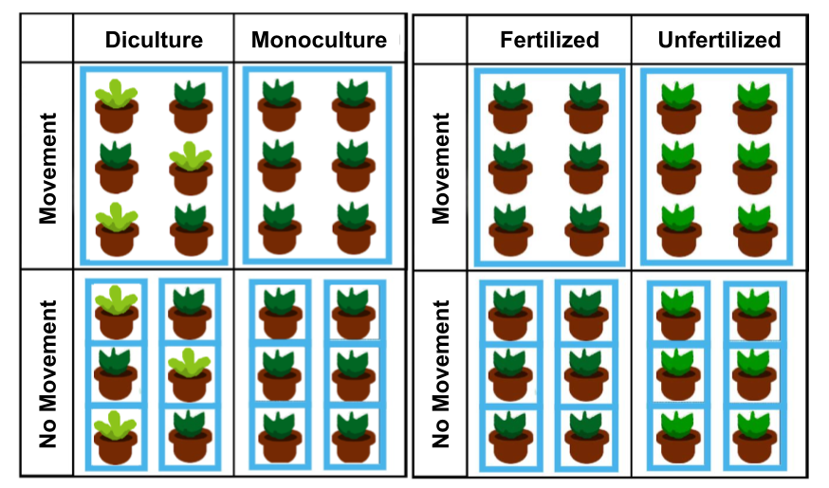
Figure 1. Associational effects experimental set-up diagram (left) and nutrient enrichment experimental setup (right). Both experiments were crossed with a larval movement treatment. The diculture planting represents kale (dark green) interplanted with mustard (light green), whereas the monoculture planting is kale only. The nutrient enrichment diagram shows fertilized (dark green) and unfertilized (light green) kale plants. Movement plantings consisted of six plants that started with one S. exigua on each plant; larvae could move among the plants during the trial. No movement plantings consisted of one S. exigua confined to one plant for the trial.

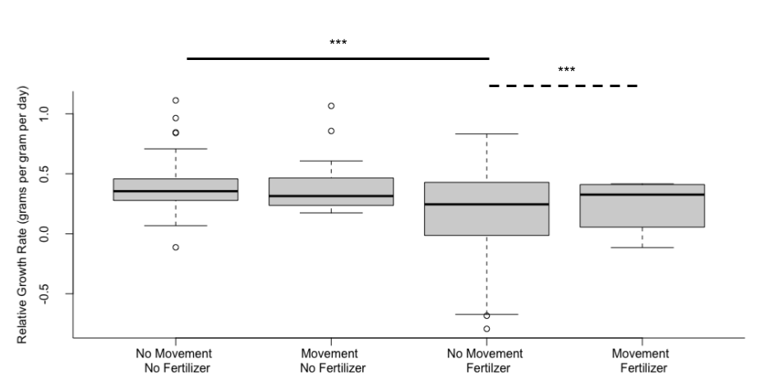
Figure 2. Effects of nutrient enrichment on variation in Spodoptera exigua RGR. The overall variation was significantly affected by treatment combination (Levene’s Test, p<0.001, df = 13,132). Significance of post-hoc Levene’s pairwise comparisons indicated by the bars above the figure (***p< 0.001, Table S1). No movement treatments represent RGR of single S. exigua that were confined to one plant, whereas movement treatments represent RGR when six S. exigua were allowed to move among six clustered plants.

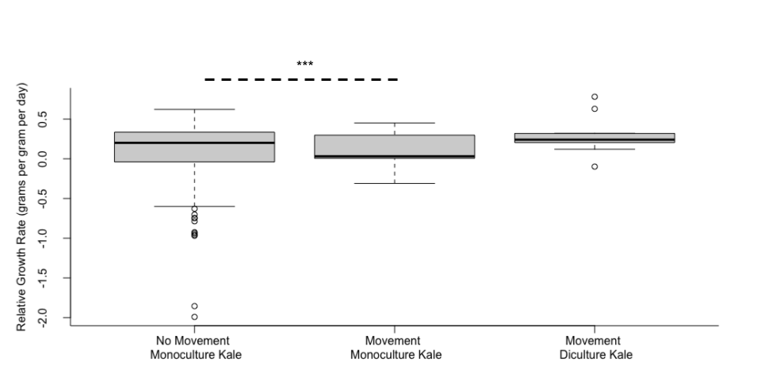
Figure 3. Associational effects influence variation in Spodoptera exigua RGR. The overall variation was significantly affected by the treatment combination (Levene’s Test, p< 0.001, df = 10,112). Significance of post-hoc Levene’s pairwise comparisons indicated by the bars above the figure (***p< 0.001). Individual treatments represent RGR of single S. exigua that were confined to one plant, whereas movement treatments represent RGR when six S. exigua were allowed to move among six clustered plants.

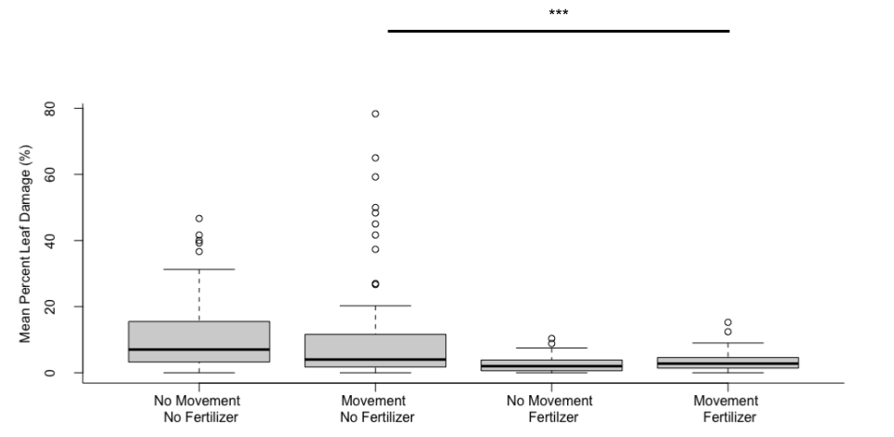
Figure 4. Effects of nutrient enrichment on variance in among plant mean percent leaf damage from the Spodoptera exigua. The overall variation was significantly affected by treatment combination (p<0.001, df = 13, 238). Significance of post-hoc Levene’s pairwise comparisons indicated by the bars above the figure (***p< 0.001). No movement treatments represent among plant mean percent damage from single S. exigua that were confined to one plant, whereas movement treatments represent among plant mean percent damage when six S. exigua were allowed to move among six clustered plants.

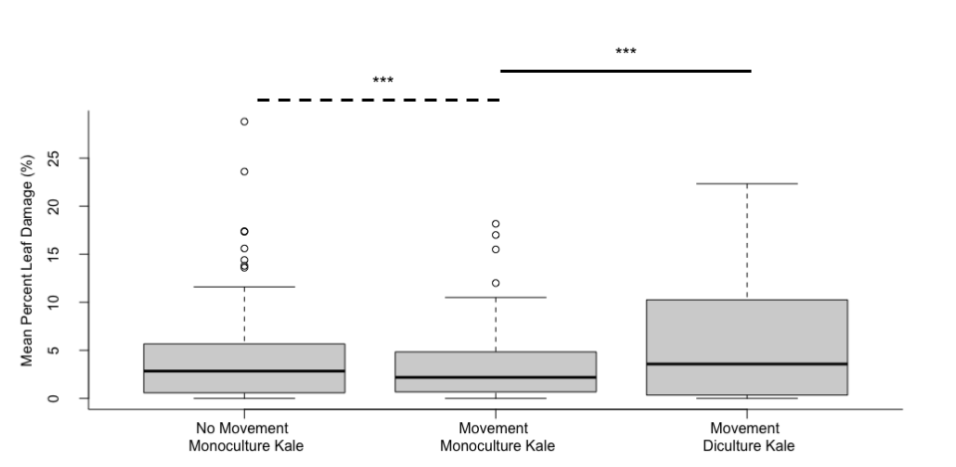
Figure 5. Associational effects influence variation in mean percent leaf damage. The overall variation was significantly affected by treatment combination (Levene's Test, df = 11,117, p< 0.001). Significance of post-hoc Levene’s pairwise comparisons indicated by the bars above the figure (***p< 0.001). No movement treatments represent among plant mean percent damage from a single S. exigua that was confined to one plant, whereas movement treatments represent among plant mean percent damage when six S. exigua were allowed to move among six clustered plants.

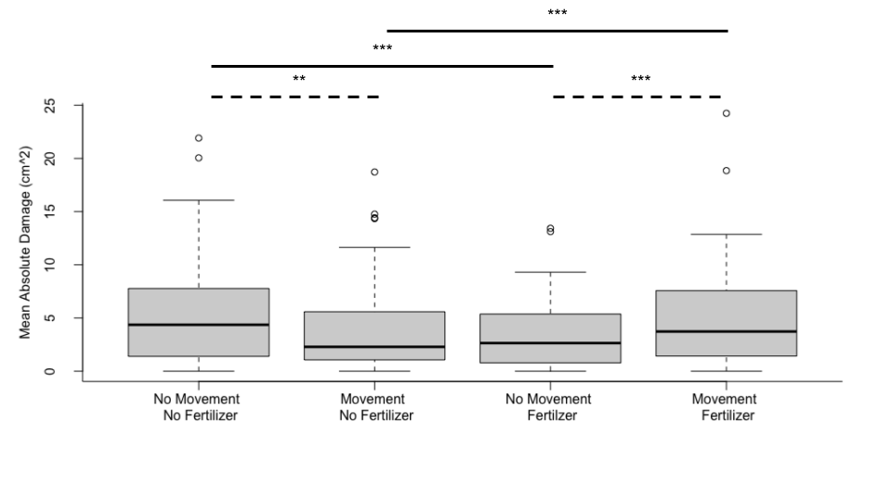
Figure 6. Effects of nutrient enrichment on variance in mean absolute leaf damage. The overall variation was significantly affected by treatment combination (Levene’s Test, p < 0.001, df = 13, 238). Significance of post-hoc Levene’s pairwise comparisons indicated by the bars above the figure ( **p< 0.01, ***p< 0.001). No movement treatments represent absolute leaf damage from a single S. exigua that was confined to one plant, whereas movement treatments represent absolute leaf damage when six S. exigua were allowed to move among six clustered plants.

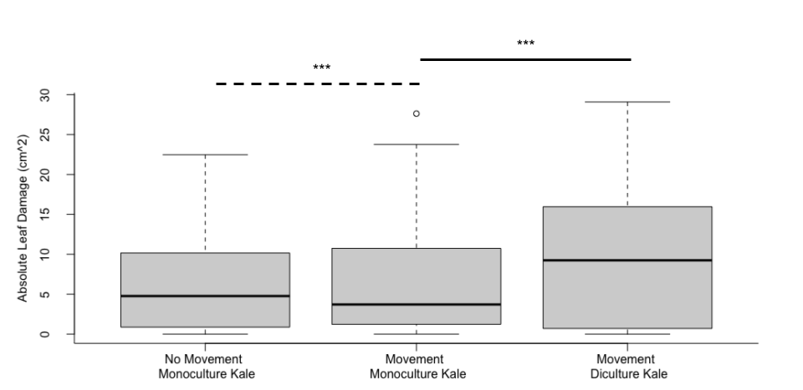
Figure 7. Associational effects influence variation in mean absolute leaf damage from the S. exigua. The overall variation was significantly affected by treatment combination (Levene’s Test, df = 8, 153 p < 0.001). Significance of post-hoc Levene’s pairwise comparisons indicated by the bars above the figure (***p< 0.001). No movement treatments represent absolute leaf damage from a single S. exigua that was confined to one plant, whereas movement treatments represent absolute leaf damage when six S. exigua were allowed to move among six clustered plants.

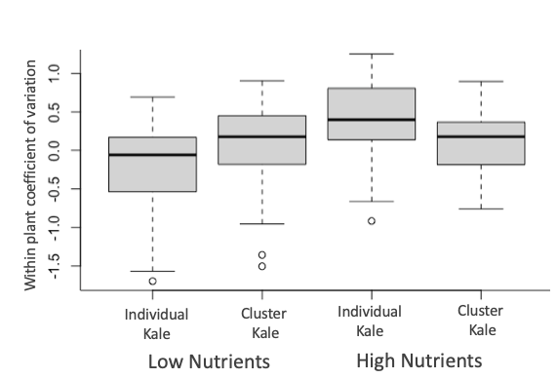
Figure 8. The overall effects of nutrient enrichment on within plant variation from the S. exigua. There was a statistically significant effect of treatment combination on the coefficient of variation (LMER, df = 3, 231, p < 0.01). No movement treatments represent within plant damage from a single S. exigua that was confined to one plant, whereas movement treatments represent within plant damage when six S. exigua were allowed to move among six clustered plants.

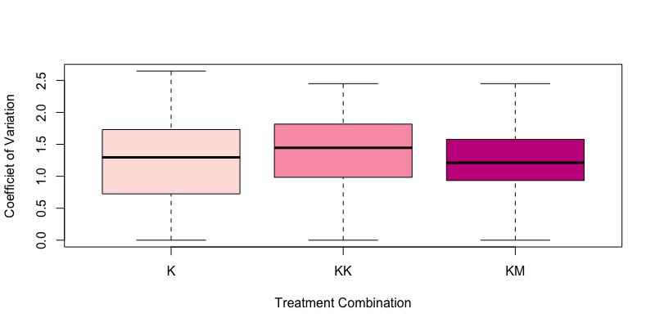
Figure 9. The overall association effects of within plant variation from the S. exigua (LMER, df = 1, p = 0.93). No movement treatments represent within plant damage from a single S. exigua that was confined to one plant, whereas movement treatments represent within plant damage when six S. exigua were allowed to move among six clustered plants.

Nutrient Enrichment Supplemental Data
S1. Nutrient Enrichment Pairwise comparisons
Pairwise comparison | Testing for? | Larval RGR |  | Percent Leaf Damage |  | Absolute Damage
Pairwise comparison | Testing for? | df | p-value | df | p-value | df | p-value
Fertilizer Movement vs. Fertilizer No movement | Effect of movement in the presence of fertilizer | 6, 74 | < 0.001 | 6, 119 | < 0.01 | 6, 119 | < 0.001
Unfertilized Movement vs. Unfertilized No movement | Effect of movement in the absence of fertilizer | 6, 58 | 0.17 | 6, 119 | < 0.001 | 6, 119 | < 0.01
Unfertilized no movement vs. Fertilized no movement | Effect of fertilizer in the absence of movement | 6, 118 | < 0.001 | 13, 238 | < 0.001 | 6, 119 | < 0.001
Unfertilized movement vs. Fertilized movement | Effect of fertilizer in the presence of movement | 6, 14 | 0.40 | 13, 238 | < 0.001 | 6, 119 | < 0.001

Associational Effects Supplemental Data
S2. Associational Effects Pairwise comparisons
Pairwise comparison | Testing for? | Larval RGR |  | Percent Leaf Damage |  | Absolute Damage
Pairwise comparison | Testing for? | df | p-value | df | p-value | df | p-value
No movement, Monoculture Kale vs. Movement, Monoculture Kale | Effect of movement in the presence of monoculture | 4,79 | < 0.001 | 5,129 | < 0.001 | 5,129 | < 0.001
Movement, Monoculture Kale vs. Movement Diculture Kale | Effect of diculture in the presence movement | 4,13 | 0.337 | 5,75 | < 0.001 | 5,75 | < 0.001

